**Retinal Vessel Classification in Fundus Images**

**Prasadam Dilip Kumara, Jaideep Tripuranib, Chinta Ujhwalc, Devanjali Reland**

a BML Munjal University, Gurgaon, India, [prasadam.kumar.19cse@bmu.edu.in](mailto:prasadam.kumar.19cse@bmu.edu.in)

b BML Munjal University, Gurgaon, India, [jaideep.tripurani.19cse@bmu.edu.in](mailto:jaideep.tripurani.19cse@bmu.edu.in)

c BML Munjal University, Gurgaon, India, chinta.ujhwal.19cse@bmu.edu.in

d BML Munjal University, Gurgaon, India, devanjali.relan@bmu.edu.in

**ABSTRACT**

The structure and features are significant elements in retinal fundus images, which indicate whether the patients suffer from eye diseases, such as diabetic retinopathy, hypertension, and glaucoma . For extracting vessel features to analyze and detect diseases in retinal fundus images, retinal vessel segmentation is essential in clinical medicine. Manual segmentation of retinal vessels by experts, on the other hand, is a time-consuming and difficult task. Noise, low contrast, irregular, and multi-scale patterns are common in retinal fundus pictures, as seen in. These factors result in the poor performance of vessel segmentation. Therefore, the automated and standard retinal vessel segmentation plays an important role in the diagnosis of eye diseases. This paper thus provides a model which tries to classify the images based on the different structure of the retinal vessels and classify the retinal images as arteries and veins.

**KEYWORDS**

Retinal fundus images,vessel segmentation

**INTRODUCTION**

Due to diseases like diabetics, hypertension, stroke, and many other cardiovascular diseases, there is always change in the structure and relationship changes in the retinal vessels. Use of image processing techniques in the digital color fundus will analyze the vasculature in a realizable approach for the diagnosis of the diseases. Retina is one of the light sensitive tissues which is multi-layered and is surrounded by the posterior cavity of the eye, the light rays are then converted into neural signals for the processing of the brain. Retinopathy refers to the common problems of diabetes which affects the vascular area of the retina. The earliest form of retinopathy is non proliferative, where the damaged blood vessels in the retina begin to leak into extra fluid of small amounts of blood that are spread into the eyes. Laser treatment can prevent the progression of damage in the eyes and the risk of blindness can be reduced to maximum extent. There are numerous methods which have been suggested for early diagnosis of the disease. The fundus imaging is one the main methods of the screening for retinopathy. The advancements in the digital imagining and imaging processing resulted in the use of image modeling and analysis technologies in all the areas of medical fields especially in the field of ophthalmology. The retinal blood vessel network that is visible in noninvasive imaging methods. The retinal fundus imaging is most used for both manual and automatic Evaluation of the vessel.

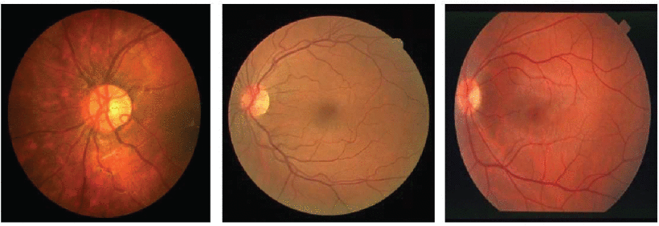

fig.1 Color Fundus Images

The analysis of the structure for the retinal vessel network is used for the tool for early detection of retinopathies. Many researchers used this analysis for the development of vessel segmentation methods. These are further expanded for the Evaluation of the vessel network. The parameters that can be measured from the retinal vessel structure are thickness of the vessels, curvature in the vessels, structure of the vessel and arteriolar venular ratio (AVR).

AVR is found out to be useful for early diagnosis of diseases like hypertension, diabetes, stroke and other cardiovascular problems in adults. Thus, AVR calculations are used for solving the problems that consist of several minute problems including optic disc localization, vessel segmentation, accurate vessel diameter measurement, vessel network analysis and classification of arteries and veins. The location of the optic disc is needed to know the region interest (ROI) in which the measurements are performed according to the protocol.

Vessel segmentation is needed for finding the exact location of the vessels and also for thickness calculation. The network analysis is thus needed for the location if bifurcations and cross over points are to be found for successful implementations of the medical protocols. The classification of arteries and veins are the fundamental steps in the measurement of AVR. Separation of veins and arteries with high accuracy is thus important because there are small errors in the classification that can lead to large errors. Hence, providing an efficient and effective method for vessel classification is important.

1. **RELATED WORKS**

**Semantic segmentation in medical images:** Many well-designed network structures based on deep convolutional neural networks show excellent performance in semantic segmentation tasks due to their rich representation capabilities. Fully Convolutional Networks (FCN) [26] is extremely crucial for the evolution of semantic segmentation. It utilizes an encoder-decoder structure and applies fully convolutional classification networks in the whole backbone to perceive features. Another important contribution in semantic segmentation is the utilization of skip-connection, which aggregates low-level features into high-level features to recover reduced details. Motivated by FCN and skip-connection, U-Net is proposed with a U-shaped encoder-decoder architecture, which modifies and extends the structure of FCN. U-Net is widely adopted in medical image segmentation and can effectively handle multi-scale features in medical images. However, in retinal vessel segmentation, U-Net is not enough to cope with the thin and irregular retinal vessel structure , though U-Net achieves multi-scale contextual information aggregation. To deal with the problem, we embed the Transfer learning into the U-Net by using two convolutional branches with a soft attention mechanism to further generate multi-scale information.

**3. METHODOLOGY**

In this work, we used a U net based model for retinal vessel segmentation. The procedure consists of two main following steps: image pre-processing and training the model. Pre-processing strategies for adjusting the contrast,size ,orientation and other such basic properties of thepaks images. The model combines Transfer learning with the U-Net.

**3.1. Dataset**

Dataset : 100 retinal images, taken from Armed Forces Institute of Ophthalmology (AFIO), Rawalpindi,

Pakistan and annotated with the help of four expert ophthalmologists for the purpose of computer aided diagnosis of hypertensive retinopathy, diabetic retinopathy and papilledema. This dataset contains retinal blood vessels network, segmented artery/ vein network to calculate Arteriovenous Ratio (AVR), annotation of Optic Nerve Head (ONH) and various retinal abnormalities such as hard exudates (HE) and cotton wool spots.

**3.2. U-net**

UNet is a convolutional neural network architecture that expanded with few changes in the CNN architecture. It was invented to deal with biomedical images where the target is not only to classify but also perform segmentation with very minute objects to segment .

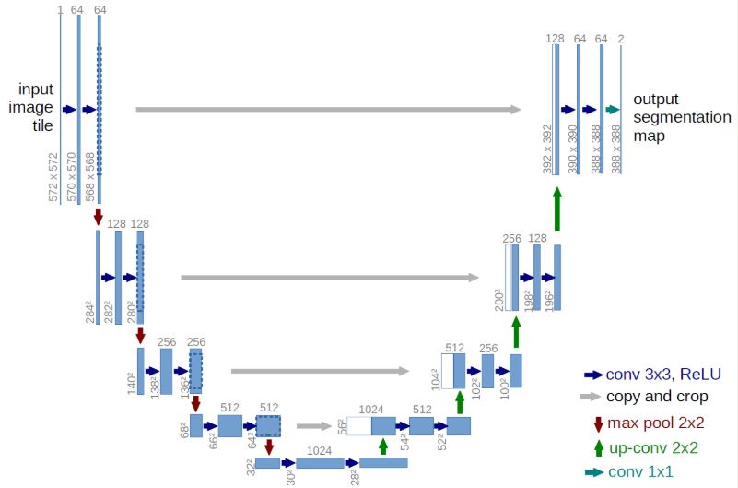

fig.2 U Net Architecture

**3.3.Transfer learning**

We have used transfer learning to implement the unet model. Using a library called segmentation models we implemented the unet architecture with the vgg16 model as the backbone architecture of the model.

### 

The model is trained with categorical_cross entropy as loss function and adam optimiser.

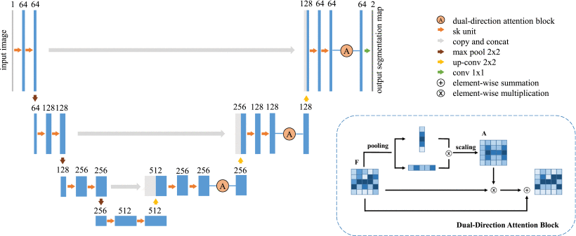

fig.3 Transfer Learning Module

### **3.4. The Algorithm of the Proposed Method**

**Input:**

x Image data

y Target mask

t Number of epochs=1000

Lr = Learning rate

**Output:**

The classified output of arteries and veins structure.

**Step 1:** Image pre-processing

Convert the images into grayscale

Adopt the contrast-limited adaptive histogram equalization

**Step 2:** Network training

Initialize Unet for the following

**for** t=0 to 1000 **do**

Compute the results

**3.5. Training Process**

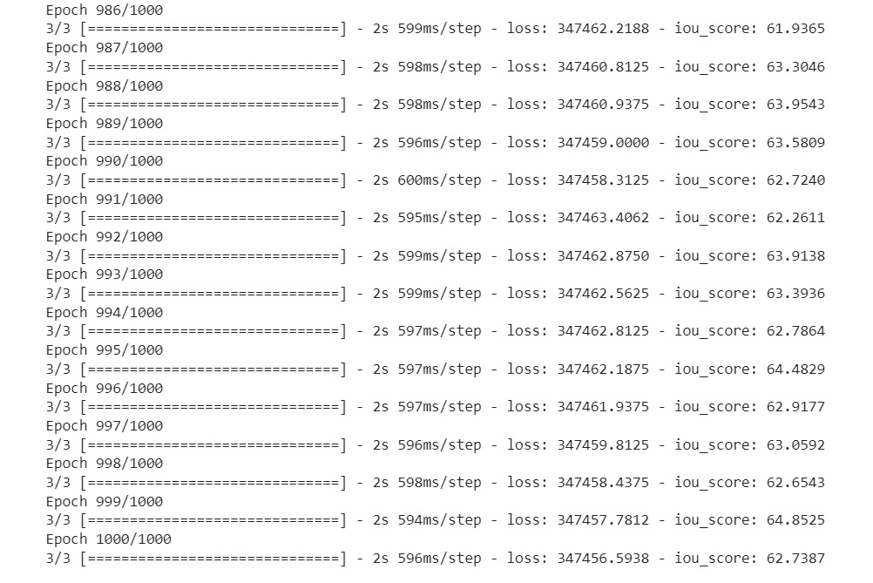

fig.4 Training Process

1. **RESULTS AND DISCUSSION**

In this paper, we propose a Unet with transfer learning for the task of automatically retinal vessel segmentation in color fundus images. Structures with noise, low contrast, multi-scale vessels, and irregular curved vessels are apparent challenges in retinal vessel segmentation. These challenges have brought great difficulties for accurate identification and classification of retinal blood vessel pixels.

**Epochs vs IOU Score Graph :**

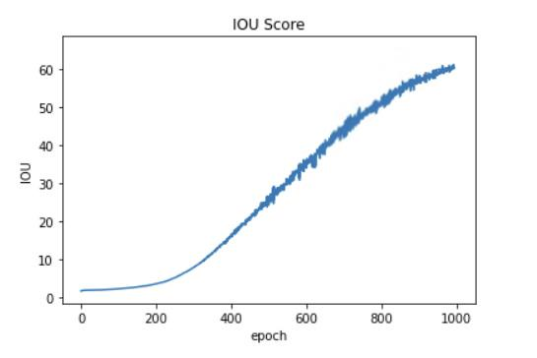

The experiment has been performed in 1000 epochs. A batch size of 32, in 100 images considered for the experiment. In the accuracy model, there has been a constant fluctuation in the validation accuracy. You can observe the Classification report which gives us a clear description of the model in the table

|  | precision | recall | iou score |
| --- | --- | --- | --- |
| 0 | 0.97 | 0.94 | 0.8 |
| 1 | 0.97 | 0.98 | 0.9 |
| 2 | 0.95 | 0.97 | 0.6 |
| 3 | 0.98 | 0.99 | 0.9 |
|  |  |  |  |
| accuracy |  |  | 0.93 |

**Table 1 Classification Report**

As the following figures fig 4 and fig 5 shows the segmentation and classification of the vessel constraint and secreted and classified with ground tooth of the artery network and vein network using the u net method.

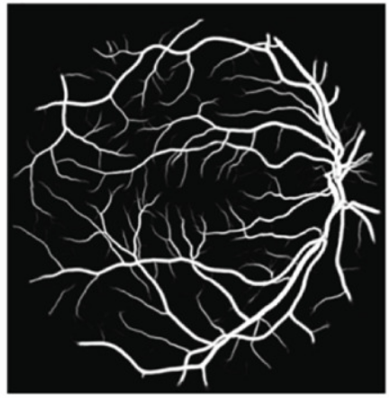 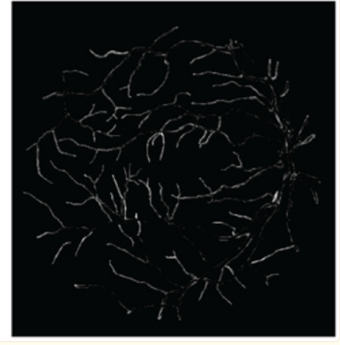

fig.4 Probability of Vessel Network fig. 5 Results after comparing with the ground truth

The following is a confusion matrix which gives us a clear idea of what are the results.i.e we can get the exact number of test cases failed and succeeded while also mentioning how many have been classified in a wrong way.

1. **CONCLUSION**

In this paper, a proposed method for artery and vein classification in fundus images are provided. Each image and the corresponding mask images are taken and trained into the unet model . Arteries and veins are trained on two different models. Using these two models , the segmentation can be carried out. The future work can be planned to use dictionary learning techniques as a part of sub division of the data adaptive models for the classification of arteries, veins in fundus images.

Among deep learning methods, U-net has performed more rapidly, with higher classiﬁcation accuracy. This method is suitable to segment and classify easily. Further, a better pre-processing technique can be applied with fuzzy thresholding concepts or nature-based algorithms for early diagnosis of dangerous medical imaging disease by adapting more layers to segment the different medical image segmentation.

1. **REFERENCES**

1. Nguyen TT, Wang JJ, Wong TY. Retinal vascular changes in pre-diabetes and prehypertension: New findings and their research and clinical implications. *Diabetes Care.* 2007;30:2708–15. [[PubMed](https://www.ncbi.nlm.nih.gov/pubmed/17595350)] [[Google Scholar](https://scholar.google.com/scholar_lookup?journal=Diabetes+Care&title=Retinal+vascular+changes+in+pre-diabetes+and+prehypertension:+New+findings+and+their+research+and+clinical+implications&author=TT+Nguyen&author=JJ+Wang&author=TY+Wong&volume=30&publication_year=2007&pages=2708-15&pmid=17595350&)]

2. Viswanath K, McGavin DD. Diabetic retinopathy: Clinical findings and management. *Community Eye Health.* 2003;16:21–4. [[PMC free article](https://www.ncbi.nlm.nih.gov/pmc/articles/PMC1705856/)] [[PubMed](https://www.ncbi.nlm.nih.gov/pubmed/17491851)] [[Google Scholar](https://scholar.google.com/scholar_lookup?journal=Community+Eye+Health&title=Diabetic+retinopathy:+Clinical+findings+and+management&author=K+Viswanath&author=DD+McGavin&volume=16&publication_year=2003&pages=21-4&pmid=17491851&)]

3. Moss SE, Klein R, Klein BE. The 14-year incidence of visual loss in a diabetic population. *Ophthalmology.* 1998;105:998–1003. [[PubMed](https://www.ncbi.nlm.nih.gov/pubmed/9627648)] [[Google Scholar](https://scholar.google.com/scholar_lookup?journal=Ophthalmology&title=The+14-year+incidence+of+visual+loss+in+a+diabetic+population&author=SE+Moss&author=R+Klein&author=BE+Klein&volume=105&publication_year=1998&pages=998-1003&pmid=9627648&)]

4. Aiello LM. Perspectives on diabetic retinopathy. *Am J Ophthalmol.* 2003;136:122–35. [[PubMed](https://www.ncbi.nlm.nih.gov/pubmed/12834680)] [[Google Scholar](https://scholar.google.com/scholar_lookup?journal=Am+J+Ophthalmol&title=Perspectives+on+diabetic+retinopathy&author=LM+Aiello&volume=136&publication_year=2003&pages=122-35&pmid=12834680&)]

5. Yau JW, Rogers SL, Kawasaki R, Lamoureux EL, Kowalski JW, Bek T, et al. Global prevalence and major risk factors of diabetic retinopathy. *Diabetes Care.* 2012;35:556–64. [[PMC free article](https://www.ncbi.nlm.nih.gov/pmc/articles/PMC3322721/)] [[PubMed](https://www.ncbi.nlm.nih.gov/pubmed/22301125)] [[Google Scholar](https://scholar.google.com/scholar_lookup?journal=Diabetes+Care&title=Global+prevalence+and+major+risk+factors+of+diabetic+retinopathy&author=JW+Yau&author=SL+Rogers&author=R+Kawasaki&author=EL+Lamoureux&author=JW+Kowalski&volume=35&publication_year=2012&pages=556-64&pmid=22301125&)]

6. Mohamed Q, Gillies MC, Wong TY. Management of diabetic retinopathy: A systematic review. *JAMA.* 2007;298:902–16. [[PubMed](https://www.ncbi.nlm.nih.gov/pubmed/17712074)] [[Google Scholar](https://scholar.google.com/scholar_lookup?journal=JAMA&title=Management+of+diabetic+retinopathy:+A+systematic+review&author=Q+Mohamed&author=MC+Gillies&author=TY+Wong&volume=298&publication_year=2007&pages=902-16&pmid=17712074&)]

7. Fraz MM, Rudnicka AR, Owen CG, Strachan DP, Barman SA. Automated arteriole and venule recognition in retinal images using ensemble classification. 2014 International Conference on Computer Vision Theory and Applications (VISAPP), vol 3, January 05, 2014. *IEEE.* :194–202. [[Google Scholar](https://scholar.google.com/scholar_lookup?journal=IEEE&title=Automated+arteriole+and+venule+recognition+in+retinal+images+using+ensemble+classification.+2014+International+Conference+on+Computer+Vision+Theory+and+Applications+(VISAPP),+vol+3,+January+05,+2014&author=MM+Fraz&author=AR+Rudnicka&author=CG+Owen&author=DP+Strachan&author=SA+Barman&pages=194-202&)]

8. Sinthanayothin C, Boyce JF, Williamson TH, Cook HL, Mensah E, Lal S, et al. Automated detection of diabetic retinopathy on digital fundus images. *Diabet Med.* 2002;19:105–12. [[PubMed](https://www.ncbi.nlm.nih.gov/pubmed/11874425)] [[Google Scholar](https://scholar.google.com/scholar_lookup?journal=Diabet+Med&title=Automated+detection+of+diabetic+retinopathy+on+digital+fundus+images&author=C+Sinthanayothin&author=JF+Boyce&author=TH+Williamson&author=HL+Cook&author=E+Mensah&volume=19&publication_year=2002&pages=105-12&pmid=11874425&)]

9. Niemeijer M, van Ginneken B, Staal J, Suttorp-Schulten MS, Abràmoff MD. Automatic detection of red lesions in digital color fundus photographs. *IEEE Trans Med Imaging.* 2005;24:584–92. [[PubMed](https://www.ncbi.nlm.nih.gov/pubmed/15889546)] [[Google Scholar](https://scholar.google.com/scholar_lookup?journal=IEEE+Trans+Med+Imaging&title=Automatic+detection+of+red+lesions+in+digital+color+fundus+photographs&author=M+Niemeijer&author=B+van+Ginneken&author=J+Staal&author=MS+Suttorp-Schulten&author=MD+Abr%C3%A0moff&volume=24&publication_year=2005&pages=584-92&pmid=15889546&)]

10. Walter T, Klein JC, Massin P, Erginay A. A contribution of image processing to the diagnosis of diabetic retinopathy − Detection of exudates in color fundus images of the human retina. *IEEE Trans Med Imaging.* 2002;21:1236–43. [[PubMed](https://www.ncbi.nlm.nih.gov/pubmed/12585705)] [[Google Scholar](https://scholar.google.com/scholar_lookup?journal=IEEE+Trans+Med+Imaging&title=A+contribution+of+image+processing+to+the+diagnosis+of+diabetic+retinopathy+%E2%88%92+Detection+of+exudates+in+color+fundus+images+of+the+human+retina&author=T+Walter&author=JC+Klein&author=P+Massin&author=A+Erginay&volume=21&publication_year=2002&pages=1236-43&pmid=12585705&)]

11. Faust O, Acharya UR, Ng EY, Ng KH, Suri JS. Algorithms for the automated detection of diabetic retinopathy using digital fundus images: A review. *J Med Syst.* 2012;36:145–57. [[PubMed](https://www.ncbi.nlm.nih.gov/pubmed/20703740)] [[Google Scholar](https://scholar.google.com/scholar_lookup?journal=J+Med+Syst&title=Algorithms+for+the+automated+detection+of+diabetic+retinopathy+using+digital+fundus+images:+A+review&author=O+Faust&author=UR+Acharya&author=EY+Ng&author=KH+Ng&author=JS+Suri&volume=36&publication_year=2012&pages=145-57&pmid=20703740&)]

12. Fraz MM, Remagnino P, Hoppe A, Uyyanonvara B, Rudnicka AR, Owen CG, et al. Blood vessel segmentation methodologies in retinal images − A survey. *Comput Methods Programs Biomed.* 2012;108:407–33. [[PubMed](https://www.ncbi.nlm.nih.gov/pubmed/22525589)] [[Google Scholar](https://scholar.google.com/scholar_lookup?journal=Comput+Methods+Programs+Biomed&title=Blood+vessel+segmentation+methodologies+in+retinal+images+%E2%88%92+A+survey&author=MM+Fraz&author=P+Remagnino&author=A+Hoppe&author=B+Uyyanonvara&author=AR+Rudnicka&volume=108&publication_year=2012&pages=407-33&pmid=22525589&)]

13. Mendonça AM, Campilho A. Segmentation of retinal blood vessels by combining the detection of centerlines and morphological reconstruction. *IEEE Trans Med Imaging.* 2006;25:1200–13. [[PubMed](https://www.ncbi.nlm.nih.gov/pubmed/16967805)] [[Google Scholar](https://scholar.google.com/scholar_lookup?journal=IEEE+Trans+Med+Imaging&title=Segmentation+of+retinal+blood+vessels+by+combining+the+detection+of+centerlines+and+morphological+reconstruction&author=AM+Mendon%C3%A7a&author=A+Campilho&volume=25&publication_year=2006&pages=1200-13&pmid=16967805&)]

14. Ikram MK, de Jong FJ, Vingerling JR, Witteman JC, Hofman A, Breteler MM, et al. Are retinal arteriolar or venular diameters associated with markers for cardiovascular disorders? The Rotterdam Study. *Invest Ophthalmol Vis Sci.* 2004;45:2129–34. [[PubMed](https://www.ncbi.nlm.nih.gov/pubmed/15223786)] [[Google Scholar](https://scholar.google.com/scholar_lookup?journal=Invest+Ophthalmol+Vis+Sci&title=Are+retinal+arteriolar+or+venular+diameters+associated+with+markers+for+cardiovascular+disorders?+The+Rotterdam+Study&author=MK+Ikram&author=FJ+de+Jong&author=JR+Vingerling&author=JC+Witteman&author=A+Hofman&volume=45&publication_year=2004&pages=2129-34&pmid=15223786&)]

15. Sun C, Wang JJ, Mackey DA, Wong TY. Retinal vascular caliber: Systemic, environmental, and genetic associations. *Surv Ophthalmol.* 2009;54:74–95. [[PubMed](https://www.ncbi.nlm.nih.gov/pubmed/19171211)] [[Google Scholar](https://scholar.google.com/scholar_lookup?journal=Surv+Ophthalmol&title=Retinal+vascular+caliber:+Systemic,+environmental,+and+genetic+associations&author=C+Sun&author=JJ+Wang&author=DA+Mackey&author=TY+Wong&volume=54&publication_year=2009&pages=74-95&pmid=19171211&)]

16. Hatanaka Y, Nakagawa T, Hayashi Y, Aoyama A, Zhou X, Hara T, et al. *Automated detection algorithm for arteriolar narrowing on fundus images. Proc. 27th Annual International Conference of the IEEE Engineering in Medicine and Biology Society (EMBS), paper, vol 291, August.* 2005 [[PubMed](https://www.ncbi.nlm.nih.gov/pubmed/17282169)] [[Google Scholar](https://scholar.google.com/scholar_lookup?journal=Automated+detection+algorithm+for+arteriolar+narrowing+on+fundus+images.+Proc.+27th+Annual+International+Conference+of+the+IEEE+Engineering+in+Medicine+and+Biology+Society+(EMBS),+paper,+vol+291,+August&author=Y+Hatanaka&author=T+Nakagawa&author=Y+Hayashi&author=A+Aoyama&author=X+Zhou&publication_year=2005&)]

17. Muramatsu C, Hatanaka Y, Iwase T, Hara T, Fujita H. *Automated detection and classification of major retinal vessels for determination of diameter ratio of arteries and veins. SPIE Medical Imaging, March 4, 2010. International Society for Optics and Photonics.* :76240J. [[Google Scholar](https://scholar.google.com/scholar_lookup?journal=Automated+detection+and+classification+of+major+retinal+vessels+for+determination+of+diameter+ratio+of+arteries+and+veins.+SPIE+Medical+Imaging,+March+4,+2010.+International+Society+for+Optics+and+Photonics&author=C+Muramatsu&author=Y+Hatanaka&author=T+Iwase&author=T+Hara&author=H+Fujita&pages=76240J&)]

18. Kondermann C, Kondermann D, Yan M. Blood vessel classification into arteries and veins in retinal images. Medical Imaging, March 8, 2007. *International Society for Optics and Photonics.* :651247. [[Google Scholar](https://scholar.google.com/scholar_lookup?journal=International+Society+for+Optics+and+Photonics&title=Blood+vessel+classification+into+arteries+and+veins+in+retinal+images.+Medical+Imaging,+March+8,+2007&author=C+Kondermann&author=D+Kondermann&author=M+Yan&pages=651247&)]

19. Martinez-Perez ME, Hughes AD, Stanton AV, Thom SA, Chapman N, Bharath AA, et al. Retinal vascular tree morphology: A semi-automatic quantification. *IEEE Trans Biomed Eng.* 2002;49:912–7. [[PubMed](https://www.ncbi.nlm.nih.gov/pubmed/12148830)] [[Google Scholar](https://scholar.google.com/scholar_lookup?journal=IEEE+Trans+Biomed+Eng&title=Retinal+vascular+tree+morphology:+A+semi-automatic+quantification&author=ME+Martinez-Perez&author=AD+Hughes&author=AV+Stanton&author=SA+Thom&author=N+Chapman&volume=49&publication_year=2002&pages=912-7&pmid=12148830&)]

20. Rothaus K, Rhiem P, Jiang X. Separation of the retinal vascular graph in arteries and veins. International Workshop on Graph-Based Representations in Pattern Recognition, June 11, 2007. *Springer Berlin Heidelberg.* :251–62. [[Google Scholar](https://scholar.google.com/scholar_lookup?journal=Springer+Berlin+Heidelberg&title=Separation+of+the+retinal+vascular+graph+in+arteries+and+veins.+International+Workshop+on+Graph-Based+Representations+in+Pattern+Recognition,+June+11,+2007&author=K+Rothaus&author=P+Rhiem&author=X+Jiang&pages=251-62&)]